Change in Land Use: Impacts for Global Warming

Amanda M. Barr
Dr. Liang Yang
Fall 2006

INTRODUCTION
Global warming has the potential to have a world-wide impact, and be impacted upon, in a variety of ecosystems. There is a distinct interconnectivity between changing land use, global warming, and future land use. Humans will be affected, as well as virtually all living species of animals and plants. Although research has been conducted regarding the response of various environments and species to global warming, there is much to be done. Variables that can affect environment and/or specie success include atmospheric temperature, atmospheric composition, ocean temperature, ocean composition and increased levels of ultraviolet (UV) radiation as a result of a thinning ozone layer. Naturally, as the changing earth shifts its use of land and resources, different environments will be influenced in distinct and characterized ways. The influence of and on forests, deserts, croplands, and urban environments will be the primary focus of this literature review.
Clouds, ice and oceans are only a few of the components of the climate system that are difficult to make detailed climate predictions, but a consensus of scientists agree that the release of fossil fuels will prevent increasing percentages of outgoing thermal energy from permanently leaving the surface of the earth. (ALLEN 2001) In 2001, the Intergovernmental Panel on Climate Change (IPCC) found that the earth will continue to warm over the course of the next 100 years due to the imbalance of incoming solar radiation and outgoing thermal radiation. This will result in several global changes including the melting of polar ice caps, aggressive global weather patterns, sea level increases, and increasing vegetation. (IPCC 2001)
FORESTS
Carbon dioxide is the second leading greenhouse gas, and is directly responsible for much of the warming trends we are already seeing today. Human use of fossils fuels is directly responsible for a 31% increase in the concentration of carbon dioxide in the atmosphere since the Industrial Revolution. (Malhi 2002) This excess carbon dioxide also has ecosystem and land use consequences for forests. Today, forests are regularly cleared to make room for agricultural land. As of 2002, 45% of the carbon dioxide increase in the atmosphere has been attributed to the loss of forest cover. (Malhi 2002)
Source: Y Malhi, P. Meir and S. Brown, 2002
The above three graphs illustrate the carbon dioxide increase over long and short time scales. Notice the second graph shows a sharp rate of increase since the 1800’s (Industrial Revolution). Finally, the third graph shows periodic/seasonal variation of carbon dioxide concentration, with a steady increase in the past 40 years. Approximately half of photosynthesizing reactions of the world takes place in forests. (Malhi 2002) Additionally, biomass sequestered in forest from both the vegetation and soil can account for considerable carbon storage. Thus, changes in global carbon cycles and sinks can greatly influence forest ecosystem. Since about 7000BC, human societies have progressively cleared forest land, resulting in large quantities of available carbon. The figure below describes the available carbon release as a function of land use change for specific countries and continents. Three major land use changes can influence the release and/or storage of carbon: permanent removal of forest land for agricultural or ranch use, urbanization, logging, and neglect of designated re-growth forest areas. (Malhi 2002)
Source: Y Malhi, P. Meir and S. Brown, 2002
Naturally, some areas of re-growth coupled with sound forest management techniques have succeeded. However, the net forest area is in a steady decline, resulting in a net increase in release of carbon.
The overall impact that forest decline has had on the atmospheric contribution of carbon is significant. It is surprising to learn, however, the degree to which the fossil fuel contribution competes with deforestation contributions. Below is a figure that illustrates the combined carbon dioxide emissions vs. fossil fuel change and land use change.

Notice that land use change only exceeded fossil fuels in the mid 1970’s. Today, however, fossil fuels account for approximately 75% of carbon dioxide emissions.
Future options to mitigate the effects of forest degradation are to prevent deforestation, encourage reforestation, reducing carbon loss by changing harvesting methods that require less logging, changing in tilling practices, and increased use of altnerative fuels. (Malhi 2002) Proper land use management should encourage these objectives.
DESERT ECOSYSTEMS
Desert ecosystems also respond to future warm climate scenarios as predicted by the greenhouse effect. They have the potential to provide major carbon sinks in both their soils and vegetation. (Lioubimtseva and Adams, 2004) Specific species will of course be influenced in different ways. Although deserts have relatively low organic carbon storage per unit area, some studies suggest that deserts and semi-desert regions may be one of the most responsive to elevated levels of carbon dioxide and the resultant changes due to the greenhouse effect. (Lioubimtseva and Adams, 2004) Deserts and semi-deserts comprise approximately 37% of the proportion of the global land surface. Some studies predict that, with a 50% increase in carbon dioxide, plant production could be enhanced as much as 70% in desert systems. Furthur, higher levels of atmospheric carbon dioxide can also decrease the influence of salinity on plant growth. (Lioubimtseva and Adams, 2004) For this reason, potential agricultural uses of land near desert areas could produce more productive crops and further enhance soil organic matter.
Indirect effects of global warming are also possible in desert regions. Changing patterns of precipitation and distribution of temperatures could change current land use practices of the desert area. Global Circulation Models (GCMs) vary widely on their prediction in this area. Several GCMs predict that some desert areas will receive enhanced precipitation, while others will become even drier. (IPCC 2001) It is important to keep in mind, however, that evapotranspiration will also increase with increased temperatures, and thus offset any enhanced precipitation. Alternatively, some desert regions have anthropogenic origins such as soil erosion, relatively permanent loss in vegetation, and deterioration of soils. Not only are there changes in biomass, but also surface albedo – which has a direct relationship in GCMs. Thus, land use can greatly influence climate systems of both the region and the entire earth.
Source: (Lioubimtseva and Adams, 2004)
The above figure illustrates the influence of land use practices on desert ecosystems. Grazing, agriculture and irrigation also can have significant impacts such as wind/water erosion, loss of biomass, loss of soil carbon (such as that mentioned in the forest portion of this paper) and salinization.
OZONE
As mentioned above, in response to increased levels of greenhouse gases, atmospheric concentrations of carbon dioxide have increased by from 280ppmv in 1750 to 367ppmv in 1999. (Lal 2003)
In addition to atmospheric carbon dioxide, the important role of ozone also has a significant impact on land use and future change. In recent years, the ozone layer that protects the earth from UV radiation has suffered from the affects of global warming. As a result, a thinning of the ozone layer in certain regions of the earth has occurred. Knowledge of how particular species respond to increased UV radiation may be ascertained through direct study of those species that have been exposed, or laboratory tests of species artificially exposed to differing levels of UV radiation. Knowledge of how one particular species reacts to increased levels of UV radiation may of significance to certain populations, including many farming communities in the Texas Area. Data of this nature can help the farming community to plan future crops that would be most successful. This would decrease profit-loss as a result of crop damage from increased levels of UV radiation, and increase productivity of farming resources.
Although some types of radiation from the sun, such as near-infrared and visible light, will be absorbed by clouds, other types interact with the ozone layer and the upper atmosphere. This type is UV radiation, and the fluctuation in UV levels can affect the size of the ozone hole. (ALLEN 2001) Increase in the total UV radiation to reach the surface may influence incidences of certain types of cancers, eye diseases, and many other problems.
The sun emits energy in a wide range of wavelengths, with increasing energy for shorter wavelengths. UV radiation has wavelengths in the range of 290 to 400 nm. UV radiation is often split between two types: UV-A and UV-B. UV-A radiation has UV wavelengths between 320-400nm, and is involved in the formation of vitamin D by humans, as well as causing sun damage to skin and eyes. UV-B, on the other hand, has wavelengths between 290-320nm, and causes damage at the molecular level to DNA. Living cells are more resilient to UV-B and have evolved DNA repair enzymes to reconstruct damaged portions. Living cells are also protected by the ozone layer, as mentioned earlier. This protects life on earth from excessive levels of UV-B radiation.
Recent research has been conducted to determine the correlation between amount of exposure to UV-B radiation and the resultant damage that it triggers. In plants, UV-B radiation harms photosynthetic abilities. (ALLEN 2001) Further, increased UV-B decreases size, productivity and quality in many crop plant species such as rice, soybeans, winter wheat, cotton and corn. (ALLEN 2001) There is also an increased susceptibility to disease. (ALLEN 2001)
UV-B EFFECTS ON CROPS
The level of increase in UV-B at a certain locations depends on several factors including the amount of ozone, position of the sun (latitude and longitude), cloud cover, and land cover of sand, snow, or water. (Kakani et al. 2002) Based on models that predict UV level increased relative to 1979-1992 levels, 2010-2020 may receive UV doses increased by 14% in the Northern hemisphere and up to 40% in the Southern hemisphere. (Kakani et al. 2002) A 30% increase in UV-B radiation levels is expected to have significant impact on crop productivity. (Kakani et al. 2002) Sensitivity to increased UV-B varies significantly among plant species. According to previous studies, approximately two-thirds of 300 species and specie varieties are vulnerable to damage from amplified UV-B levels (Teramura and Sullivan 1991) The extent of damage may vary seasonally and can be affected by microclimate and soil fertility. (Teramura and Sullivan 1991) The wide variety of responses to different environmental conditions can be seen with soybeans. Soybeans are less susceptible to UV-B radiation if under water stress or mineral deficiency. (Teramura and Sullivan 1991) However, under low levels of visible radiation, sensitivity actually increases. (Teramura and Sullivan 1991) Analysis of different environmental factors, such as decreased water supply, decreased and/or increased visible light supply, and decreased and/or increased mineral availabilities may also be considered. Modeling of this sort enables land management scientists to skillfully plan to future land use practices as a direct result of global warming.
The most commonly used method for simulating increased UV-B radiation is through the use of artificial lamps. These lamps, however, have a slightly different spectrum than that from the resultant radiation from ozone depletion. Many simulations thus use a weighting function that is species-specific. (Callaghan et al. 2004) Globally, studies have shown that there is a significant diminution of plant biomass and plant height when exposed to increased UV-B. (Callaghan et al. 2004) Because one ozone thinning location is in the Arctic, much research has been conduction in that area. Studies of plant species in that location show that Arctic species are more tolerant of enhanced UV-B radiation than expected (Callaghan et al. 2004) Further, there was no simple relationship found between UV-B absorbing compounds to UV-B exposure level. (Callaghan et al. 2004) This may suggest other unknown mechanisms that interact with UV-B tolerance. It also may be possible to genetically modify plant crops to resist effects of increased exposure to UV-B through UV-B absorbing compounds mentioned previously.
CROPS ALREADY TESTED
According to Table 1(Kakani et al. 2002), one can see a list of major cereal, oilseed, fiber, and protein crops that were experimentally tested for their response to increased levels of UV-B. Currently, North American crops receive 4-11 kJm-2 per day of UV-B. (Kakani et al. 2002) This range is expected to increase to 4.56-12.54 kJm-2 during the 2010-2020 time period. (Kakani et al. 2002) The crops listed below have been evaluated for UV-B levels ranging from 0-49 kJm-2.
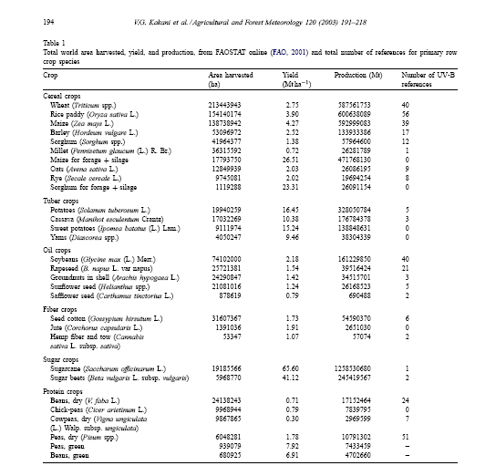
Table 1: Crops Tested for UV-B radiation response

In response to the UV-B conditions, a number of symptoms were reported such as changes in leaf color and form, leaf thickness and structure, and affects on photosynthesis. (Kakani et al. 2002) Specifically regarding photosynthesis changes, most crops tested showed a reduction in chlorophyll content and damage to chloroplasts and changes to photosynthetic pigments. (Kakani et al. 2002) The net result was a decrease in photosynthesis. Table 2 (Kakani et al. 2002) describes the responses of particular crop species.
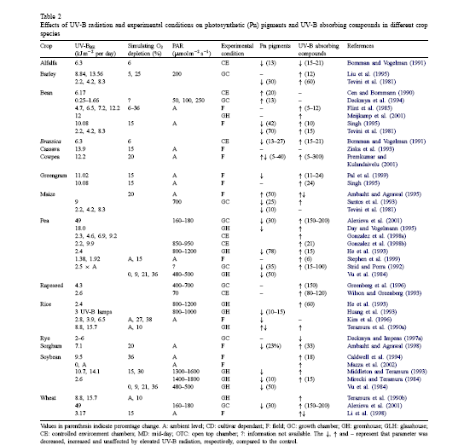
Table 2: Effect of UV-B Radiation
It is important to note the wide variety of responses, even among one particular species, can result from different experimental conditions of specific researchers. Variations in other parameters are numerous.
URBAN
Urban land use practices are often governed by political parties and agendas. For this reason, majority support for global warming and future climate changes is essential to properly plan urban land in the future. Possible implications for urban areas include sea level rise, drought, urban heat island effects, changing groundwater resources, enhanced/decreased potential for rain, increased temperatures, and potentially greater probabilities of hurricanes. The Environmental Protection Agency (EPA) recommends that cities and states enact action plans that identify not only ways to reduce greenhouse gas emissions, but also to mitigate negative impacts on global warming.
According to the IPCC (2001), sea level rise alone, enhanced by the warmer temperatures, may increase current global average sea level by .3-2.9 feet over the next 100 years. This will impact urban areas by eroding beaches, intensifying flooding, and influences salinity and groundwater stores. In addition, many people own “beach front property” that will be costly to protect against the encroaching sea level rise. Some states, such as North Carolina, have enacted laws that prohibit residents from building new houses in areas that are likely to be eroded in the next 30-60 years (EPA website).
FINAL THOUGHTS
Land use has contributed to global warming, and global warming will dictate future land use. Societal education about global warming can both help reduce the severity of global warming, as well as mitigate potential impacts. Enormous economic impacts will probably influence people to a greater degree than scientific evidence. Higher taxes will inevitably ensue to protect the large cities along the coast, to preserve what few forests are left, to decrease desertification, and research future agricultural land use.

References

Allen, Jeannie. Ultraviolet Radiation: How it affects life on earth. 6 September 2001. Accessed Online, http://earthobservatory.nasa.gov/Library/UVB/, 30 November 2005.

Callaghan, Terry V., Björn, Lars Olof, Chernov, Yuri, Chapin, Terry, Christensen, Torben R., Huntley, Brian, Ims, Rolf A., Johansson, Margareta, Jolly, Dyanna, Jonasson, Sven, Matveyeva, Nadya, Panikov, Nicolai, Oechel, Walter, Shaver, Gus, Elster, Josef, Jónsdóttir, Ingibjörg S., Laine, Kari, Taulavuori, Kari, Taulavuori, Erja, Zöckler, Christoph. 2004. Responses to Projected Changes in Climate and UV-B at the Species Level. AMBIO: A Journal of the Human Environment, Volume 33, Number 7, Pages 418–435.
EPA, 1989: The Potential Effects of Global Climate Change on the United States. Report to Congress. Washington, D.C.: U.S. Environmental Protection Agency. EPA 230-05-89-052. http://www.epa.gov/climatechange/effects/coastal/1989report.html
IPCC, 2001: Climate Change 2001: Impacts, Adaptation and Vulnerability. Contribution of Working Group II to the Third Assessment Report of the Intergovernmental Panel on Climate Change [McCarthy, J.J., O.F. Canziani., N.A. Leary, D.J. Dokken, and K.S. White (eds.)]. Cambridge University Press, Cambridge, United Kingdom and New York, NY, USA, 1032 pp. http://www.grida.no/climate/ipcc_tar/wg2/index.htm

Malhi, Y., Meir, P., and Brown, S., 2002. Forests, Carbon and Global Climate. The Royal Society, Volume 360, Pages 1567-1591.

V. G. Kakani, K. R. Reddy, D. Zhao and K. Sailaja, Field crop responses to ultraviolet-B radiation: a review, Agricultural and Forest Meteorology, Volume 120, Issues 1-4, 24 December 2003, Pages 191-218.

Lioubimtseva, E., Adams, J.M., 2004. Possible Implication of Increased Carbon Dioxide Levels and Climate Change for Desert Ecosystems, Environmental Management, Volume 33, Supplement 1, Pages S388-S404.

Teramura, A. H. and J. H. Sullivan. 1991. Potential impacts of increased solar UV-B on global plant productivity. Photobiology, ed. E. Riklis, Pages 625-634.

